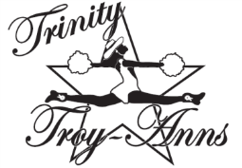
PLEASE SUPPORT THE
TRINITY TROY-ANN DRILL TEAM

With your donation you will receive:
- Free Advertising
- Donation Letter for Tax Purposes
- Sponsorship Sign to display and show your support of the Trinity Troy-Anns to the Community (These will be delivered in August.)
Donation Levels:

PLATINUM ($250+)
- Company name on Troy-Ann community shirts
- Company name will run on the Pennington Field electronic sign @ Trinity home football games and will be announced at a Trinity Home football game as a Troyann Sponsor of the Week.
- Company name placed on the Troy-Ann website
- Business card size ad in performance program
- Large business logo on our banner

GOLD ($100)
- Company name will run on the Pennington Field electronic sign @ Trinity home football games.
- Company name placed on the Troy-Ann website
- Business card size ad in performance program
- Business name listed on our banner

SILVER ($75)
- Company Name placed on the Troy-Ann Website
- Business Card Size Ad in Performance Program.

BRONZE ($50)
- Business Card Size Ad in Performance Program.

COPPER ($25)
- Company Name listed in Performance Programs
**PLEASE MAKE CHECK PAYABLE TO TRINITY HIGH SCHOOL with TROYANNS in the MEMO**

