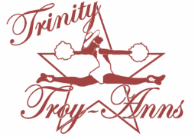
PLEASE SUPPORT THE
TRINITY TROY-ANN DRILL TEAM

With your donation you will receive a donation letter for tax purposes and …

Donation Levels:
PLATINUM ($500)
- Sponsor’s name will be announced at half time at all football games
- Sponsor’s will receive an 8X10 framed acknowledgement and team photo
- All Gold, Silver, Bronze and Copper recognitions as well.

GOLD ($300)
- Sponsor’s Name will run on the Pennington Field Electronic Sign @ Trinity Home Football Games.
- Sponsor's name will be listed on the Dance Clinic Shirts
- All Silver, Bronze and Copper recognitions as well.

SILVER ($150)
- Sponsor's name will be listed on the Troy-Ann Sponsor banner, that is at every football game
- All Bronze and Copper recognitions as well.

BRONZE ($100)
- Personalized 4X6 thank you card from the Troy-Anns
- All Copper recognitions as well.

COPPER ($50)
- Sponsor's Name listed in Trinity Dance Department Spring Show Program.
- Sponsor's Name and Logo on the Troy-Ann website.
- Sponsorship Sign to display and show your support of the Trinity Troy-Anns to the Community (These will be delivered by September.)

*****PLEASE MAKE CHECK PAYABLE TO TRINITY TROY-ANNS BOOSTER CLUB****

